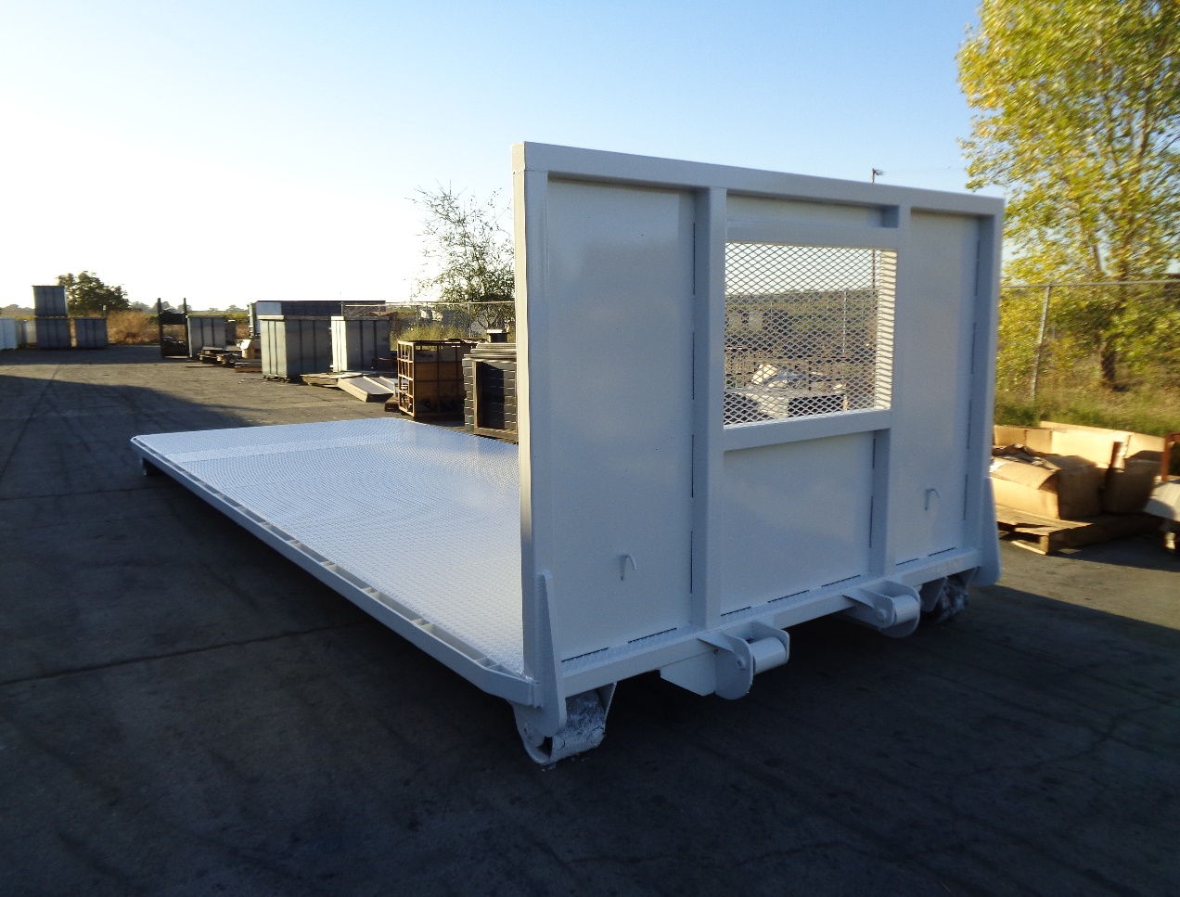
Standard Specifications
- 12’ to 24’ Long
- 7 GA. Floor Diamond Plate 12” to Ground
- 4’ Headboard w/Expanded Metal Window
- 6”x2”x1/4” Tubing Main Rails or 6” Channel
- 3” Channel Crossmembers on 16” Centers
- Basic Hook Up Options Included (A-Frame Extra)
- 8”x8” Boogie Wheels or Stands 12” Floor Height
- 96” Wide Deck (Fits Most Tarping Systems)
- Rub Rail & Stack Pockets (3” Channel)
- Painted Black or White
- Underseal Under Floor
Options
- Front Push Plate ¼” & Stack Holders
- Winches Fixed or Sliding
- Sloped Rear Ramp
- D-Rings With & With Out Recess
- Flat Steel or Other Gauges
- Recess Wheels 10” to Ground
- 102” Wide Deck
- Choice of Paint Colors

